CS 501 Project Report

Sanam Jena (10454295)

I decided to do Final Project IV as my choice for the final project. I choose 5 problems from chapter 15 they are Ex 28, Ex 29, Ex 31, Ex 32 & Ex 33. Each application has individual run interactions to play the games.

**C15E28Fan**

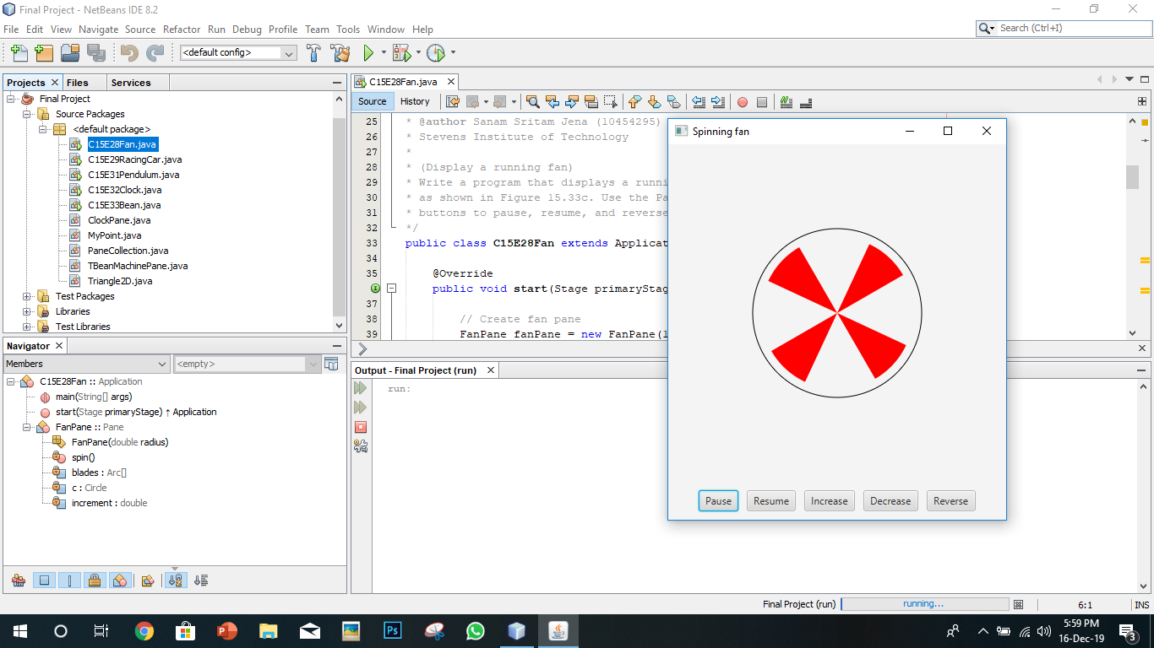

In order to begin this game, click on resume first then the fan starts to spin. In order to increase the speed of rotation of the click on increase and decrease decreases the speed of rotation of the fan. Reverse in this case reverses the direction of rotation of the fan. Pause button pauses the spinning fan.

**C15E29Car**

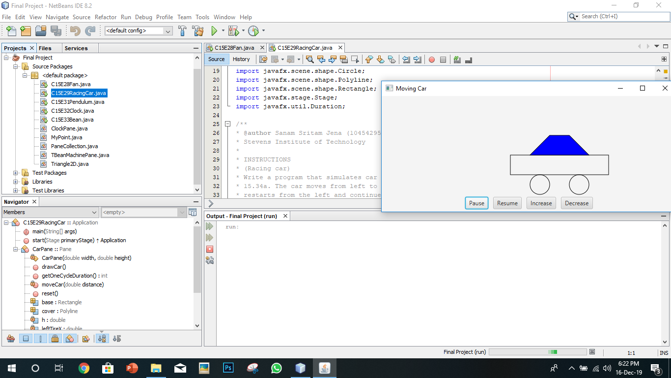

When you run the program, the car starts moving from left to right. Increase/Decrease button works to increase the speed of the car, the same can be controlled by pressing the Up and Down arrow keys as well. Pause pauses the car and then Resume resumes the car.

**C15E31Pendulum**

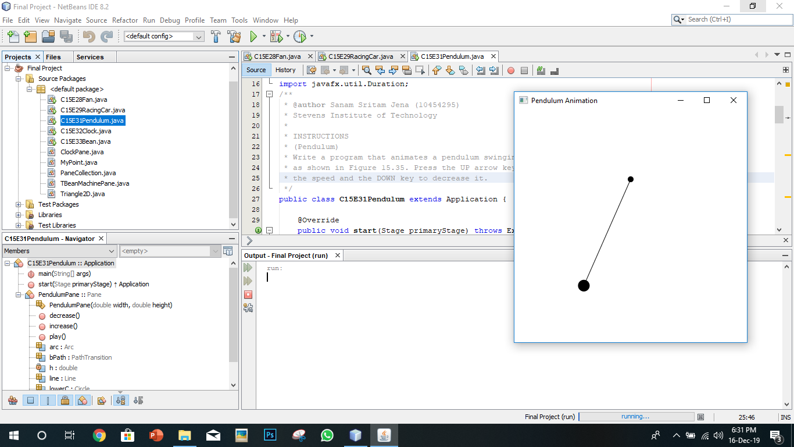

In order to play the game, we need to press up and down arrow in order to increase and decrease the speed of the pendulum.

**C15E33Bean**

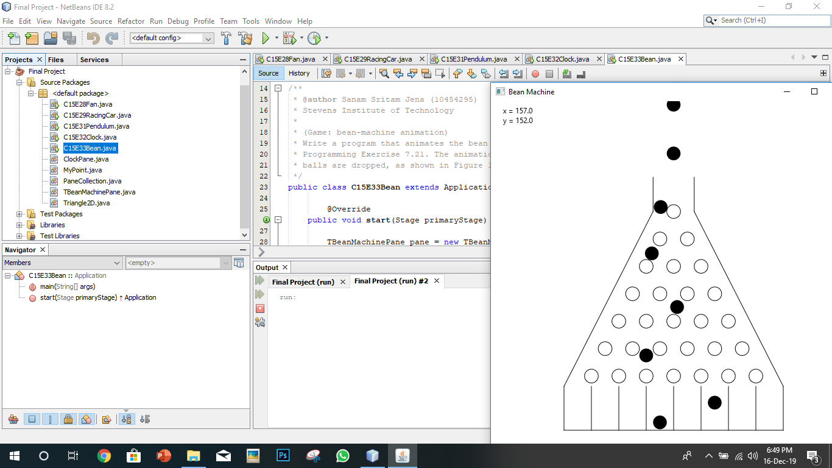

This is a game which has been modified a bit instead of the original which says the game stops after 10 balls are dropped but this game stops after 9 balls are dropped.

**C15E32Clock**

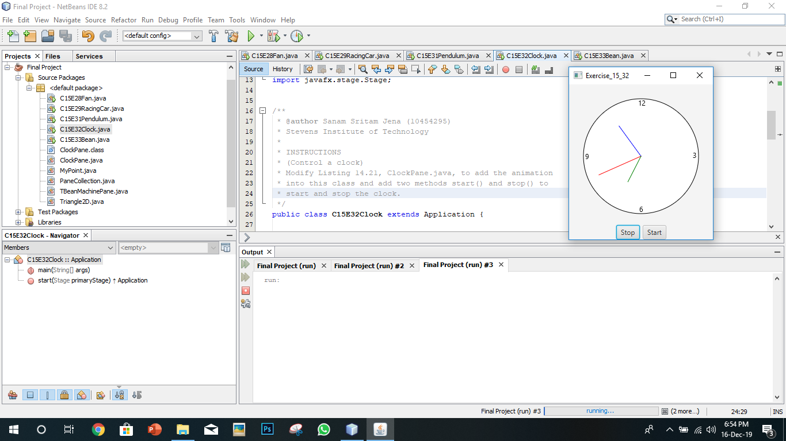

When you run the applications, the clock starts with the current system time. There are two buttons start and stop which start and stop the clock at any given time when the user clicks the buttons.